MACH4METAL

metalworking machinery
Transito 21
6909 DA BABBERICH Netherlands
Tel. +31 (0)316-247123
Fax: +31 (0)316-247956
info@mach4metal.com
www.mach4metal.com

Bank No : 66.52.13.883
IBAN : NL33 INGB 0665 2138 83
BIC : INGBNL2A

Walter Eckold Manual flanging machine

Portable manual flanging machine
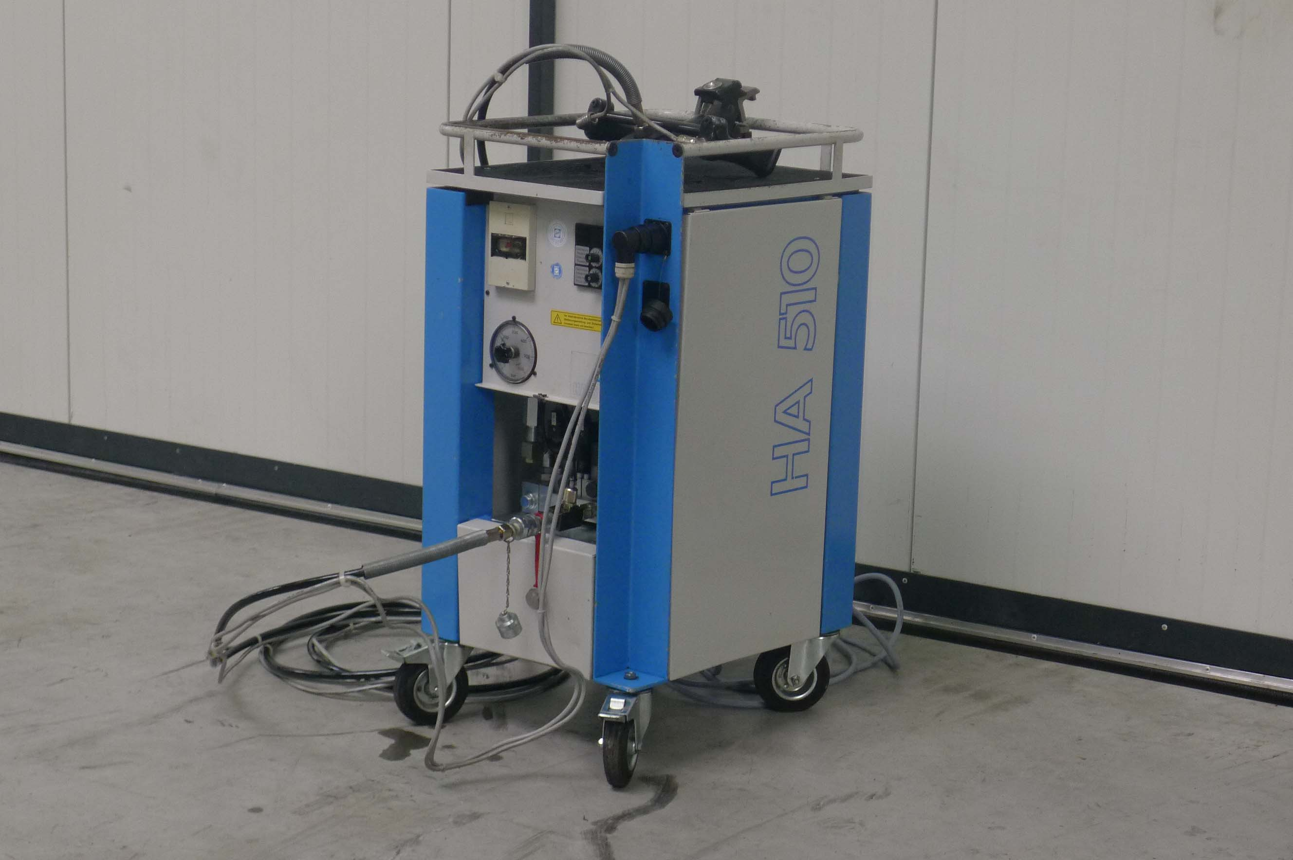

- Make : Walter Eckold
- Typ : MZ 20
- Age : 1996
- Serial : 1554 / 3590

- Throat Hor : 30 mm
- Throat Vert : 40 mm
- Length : 220 mm
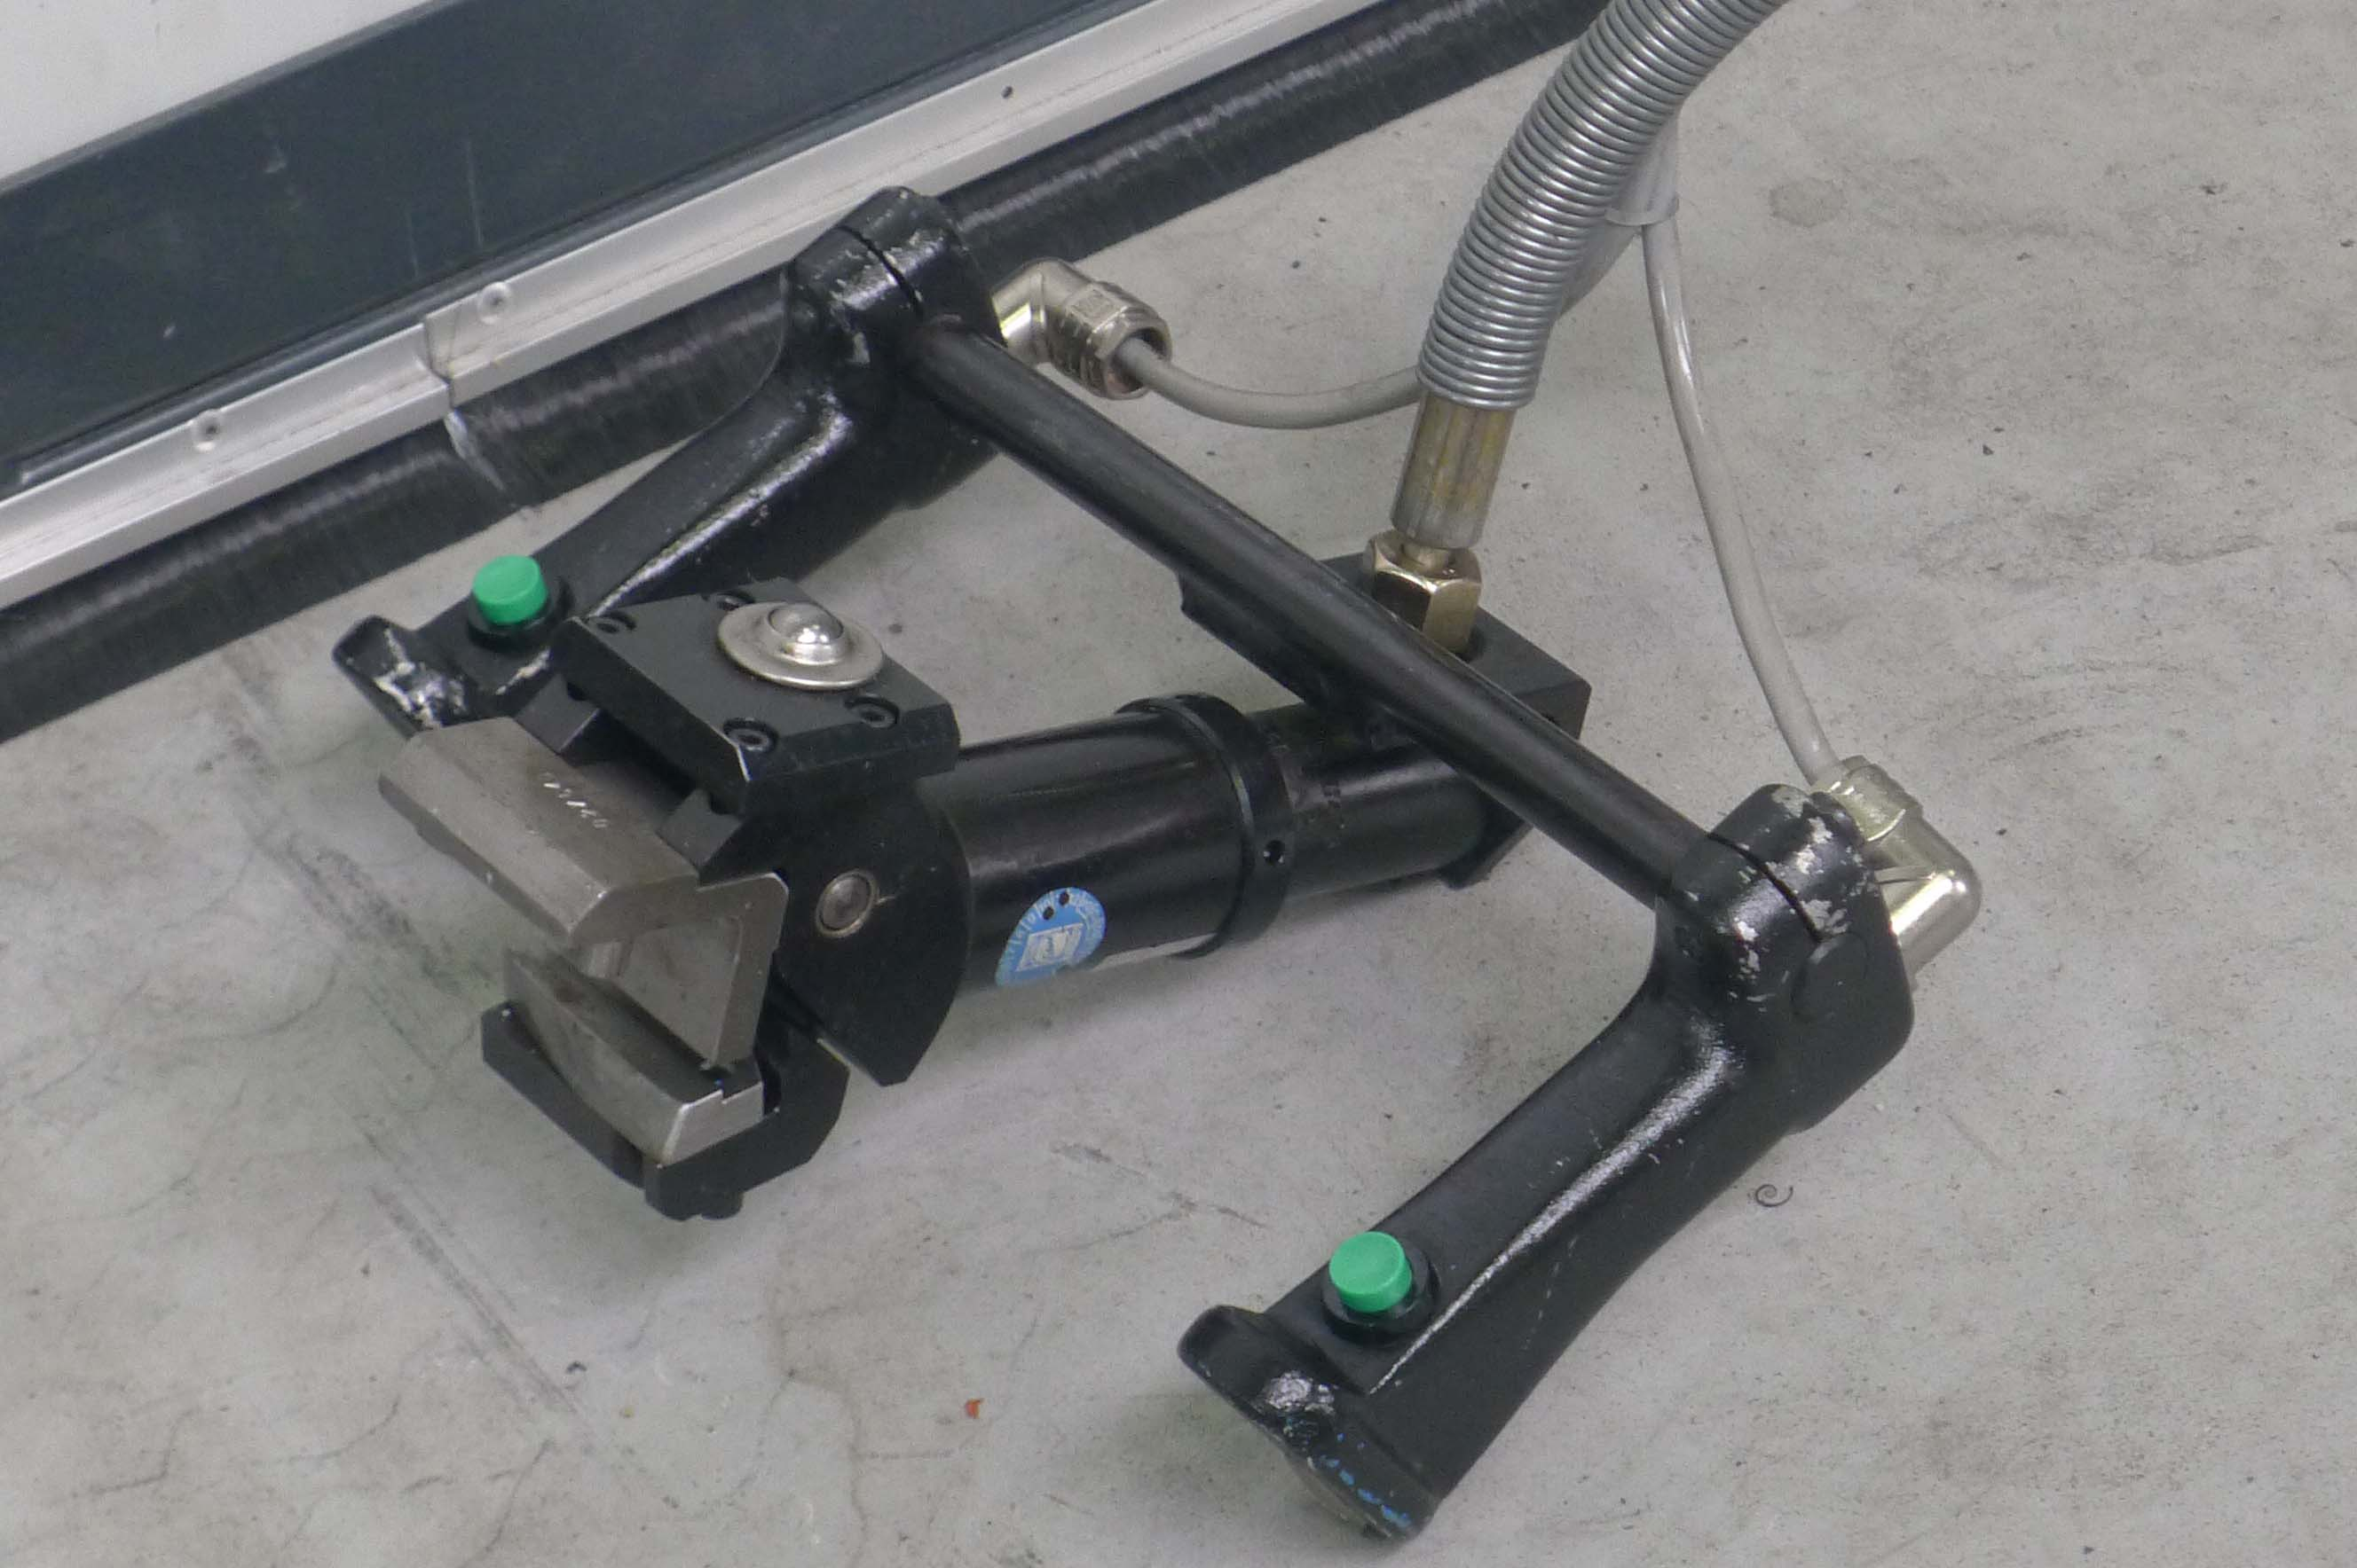
- Height : 90 mm
- Forming capacity : 2 mm

Hydraulic drive unit:

- Make : Walter Eckold
- Typ : HA 510
- Age : 1996
- No. : 895 / 574
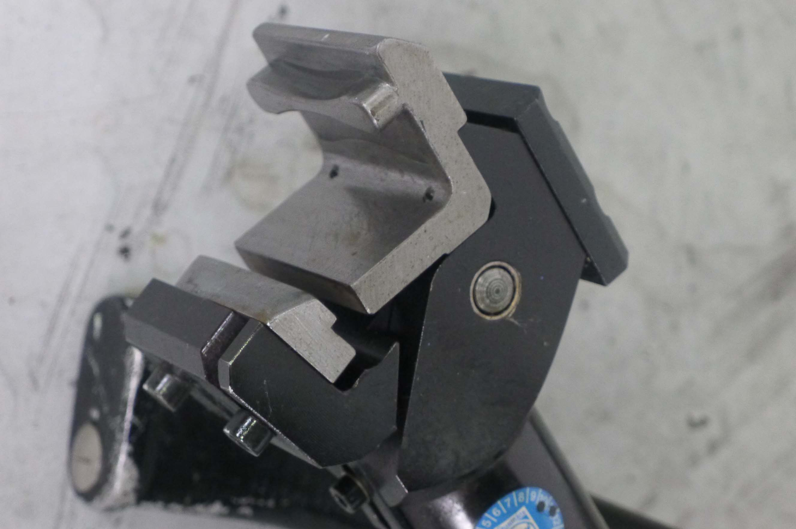
- Working pressure : 20 – 500 bar
- Oil pump l/min :530 Bar
- Hydraulic oil : 16 L
- Single action : 1 x
- Stroke’s : 20 – 60

- Power 400 V / 3.1 kW
- Dimensions
- Length : 540
- Width : 450
- Height : 970
- Weight : 130

Please Note: The above information has been obtained to the best of our ability and belief from, and from the manufacturers where possible. It is given in good faith, but its accuracy can not be guaranteed. Accordingly, it will not form a representation or constitute contractual terms. We advise you to check any vital details!

